Dashboard Cards

After you log into Kuali Research, you will see the Dashboard Home page. There are three sections called cards – Proposals routing to me, Proposals not routing, and Proposal workload assignments – that relate to Proposal Development activities.

If you are not a Proposal Creator, Approver or Viewer, you may want to bypass this page and go directly to a different page like “Common Tasks,” “All Links,” or “Search Records” to best suit your needs. You may elect to hide any cards you wish not to see by clicking on the “Show/Hide Cards” button and toggling each.

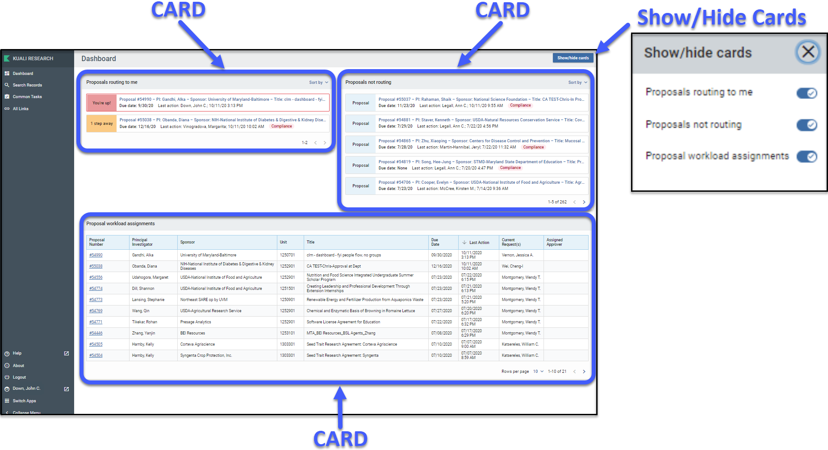

“Proposals routing to me” Card
This card allows Proposal Development Approvers to easily monitor proposals that are queued up for their approval and watch for proposals they will soon have to approve. The colored “steps” tab shows you proposals that are available for your immediate approval or if it’s one or more steps away. Each entry includes a summary of information such as the proposal’s due date (deadline) and who took the last action.

To open a proposal for review/approval, click on the item. As usual, if the proposal is at your stop and ready for approval, you will see the Approve and Return buttons.

Once the proposal is approved at your stop (by you or an alternate), it will be removed from this card. If a proposal is recalled or returned, it will also be removed from the card.
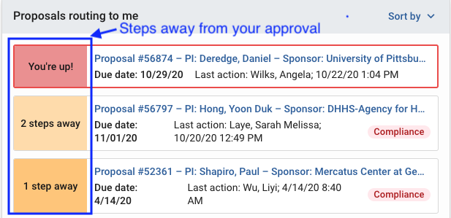

“Proposals not routing” Card
This card allows Proposal Development Approvers to monitor which proposals have been created and not yet submitted for approval. Proposal Creators may use this card to monitor which proposals they are still working on and haven’t been submitted for approval yet. To open a proposal to view or edit, click on the entry. If you are a Proposal Creator with edit rights in the Proposal’s Lead Unit, you will be placed in edit mode after clicking on the entry.

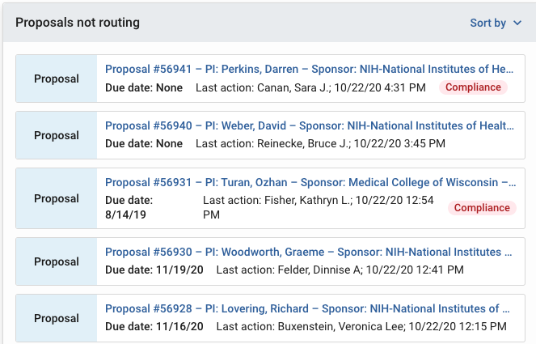

Features of the “Proposals routing to me” and “Proposals not routing” cards

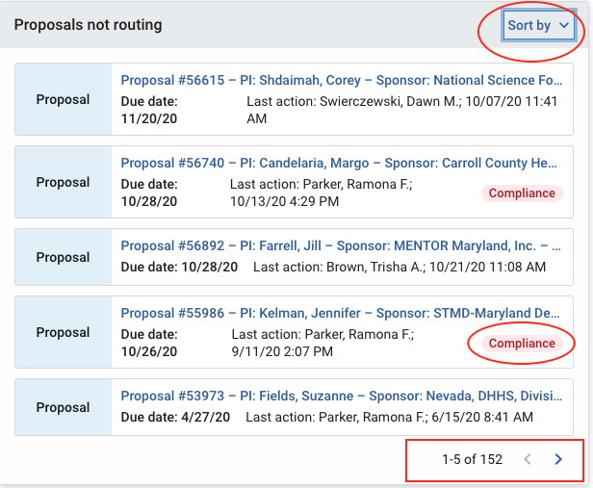 | Sorting Options  Compliance Items Tab  View Additional Records

Compliance Items Tag
If a proposal has a Compliance item listed, click on the “Compliance” Tag to get a quick view of each item and its status.
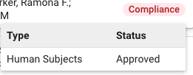

View Additional Records
You can see the total count of records in each card and navigate through the full listing by clicking on the directional buttons in the bottom right (< >).

Sorting Options
You have options to sort the entries in each card based on card content and your preferences:
- Deadline Date - Sort by the proposal deadline. (NOTE: If a deadline date wasn’t added by the proposal creator it will be at the end of your list in both ascending and descending order)
- Last Action Taken - Sort proposals by the most recently approved or saved activity.
- Principal Investigator - Sort proposals by PI.
- Proposal Number - Sort proposals by Proposal Number.
- Sponsor Name - Sort proposals by Sponsor Name.
- Step to Approve - (Only for “Proposals routing to me”) Sort proposals by how many steps until they require your approval.
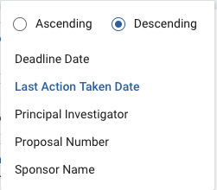

Proposal workload assignments Card

This card allows anyone with Proposal view access to see which proposals are still currently in the process of being approved across all routing stops. This card shows each proposal after it has been submitted for approval, throughout the entire approval process. The “Current Request(s)” column shows who the current primary approver is (e.g. Department, Dean, SPA team). Click on the proposal number to view a record.

Currently the “Assigned Approver” field is blank. Going forward, SPA will use this field to show the SPA team member to whom the proposal has been assigned for review.

Once a proposal has been completely approved it will be removed from this card. If a proposal is recalled or returned, it will also be removed from the card until it gets submitted into approval again.

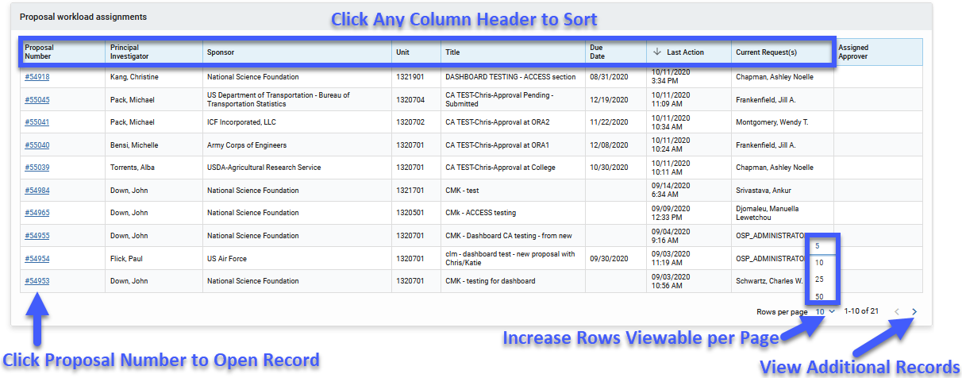
View Additional Records
At the bottom right of the card, you can see how many records are in the card. Navigate through the full listing by clicking on the directional buttons in the bottom right (< >). You may change the number of records visible per page by clicking on the “Rows per Page” option and selecting a number.

Sorting Options
Sort any column by clicking the column header to view either in ascending or descending order.
Hints and Tips!
Refreshing
When you return to the Dashboard page after approving or taking a related action in a proposal, you may not see those changes instantly reflected on the Dashboard page. The Dashboard page will refresh automatically every 5 minutes. If you would like to refresh your results sooner than that, click on the refresh button in your web browser. (Shortcut Keys: “F5” in Windows, “Command” + “R” on Macs).
NOTE: Clicking on the Dashboard button () does not refresh the page while you are currently on it.
Data Override Warning
If a user (SPA, CCT, or Dean’s Office) performs a data override operation during the routing of a proposal in order to update the deadline date, title, or other data, this may not be reflected in the dashboard cards themselves, but will be correctly shown within the record when you open it.

