Principal Investigator Certification in Kuali Research

Upon notification to certify, or at any time before the proposal is submitted for review and approvals, the Principal Investigator may certify the proposal.

Only the Principal Investigator may certify the proposal. This certification represents the PI’s electronic signature for the proposal.
- Search for and review a Proposal: Page 1
- Navigate to Certification in a Proposal After Review: Page 3
- PI Email Notification and Certification: Page 4

PI Proposal Review

The PI certifies that “To the best of my knowledge, the information submitted within the proposal is true, complete, and accurate.” In order to confirm that, the PI should review the proposal and budget.

Log into Kuali Research

Click on the link in the notification email, which will open the certification questions for response (see detailed instructions, page 4)

OR, search for your specific proposal
- Find your proposal in the Dashboard card, Proposals not routing. Sort the proposals Descending by Last Action Taken Date. Click on the blue text to open the proposal. Make sure you are in EDIT mode.
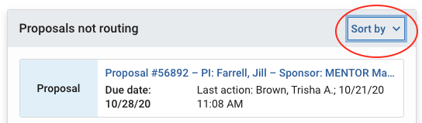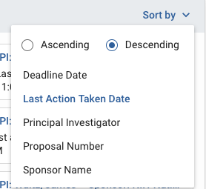

- Find your proposal via Search Proposals: from the left navigation menu, select Common Tasks. In the Proposal Development card, click on Search Proposals and enter your Proposal Number in the first field.

Enter the Proposal Number and Search: Obtain the 5-digit Proposal Number from a notification email or from the proposal initiator
OR search by investigator name and title, using *asterisks* for a wild card search.
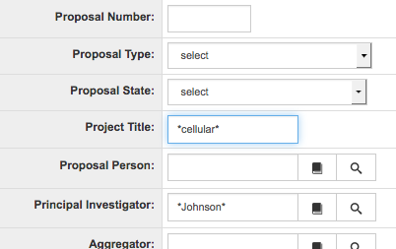

Scroll down for results. You will have permission to View as the PI. If you have been given permissions by the proposal initiator, you will also have a link to Edit.
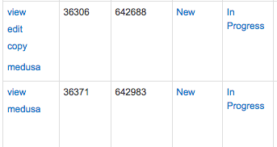

NOTE: To certify the proposal you MUST open in Edit mode. If this option does not appear, ask the proposal creator to give you access to the proposal (on the Access section, with the role “Aggregator Only Document Level”).

To review the proposal, open in either View or Edit mode. Use the left navigation menu to review the various sections of the proposal, or navigate to the Summary/Submit section, from which you can view virtually all details of the proposal within the same section by clicking on the tabs across the page.
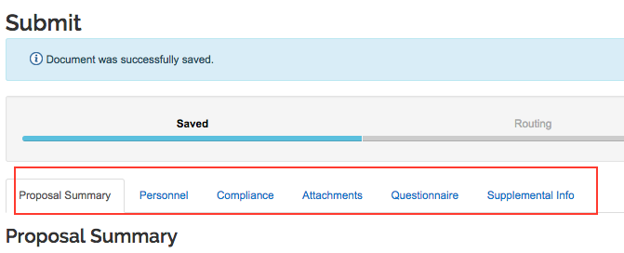

PI Certification

Using the proposal left navigation menu, navigate to Key Personnel > Personnel
Then, to the left of the PI name, click the triangle to open the PI details
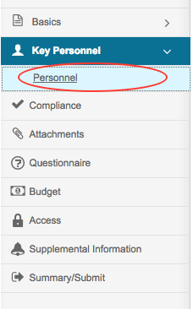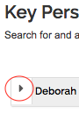

Below the PI name bar are tabs across the page. Select the Certification Questions tab

Respond to the questions. REMINDER: You must be in Edit mode to respond to the questions.
Click Save at the bottom of the page.

When you are ready, click Close at the bottom of any page to close the proposal.

Notification to PI

- The proposal aggregator clicks the “Notify” button in the proposal, Key Personnel > Personnel
- The PI receives an email notification with the subject line, “Regarding your involvement in Development Proposal [Proposal Title]”
- PI logs into Kuali Research

In the email text there is a link to the proposal number. The text is similar to this:
Please review the following proposal by clicking on Proposal Number. Please answer the certification questions if you agree to participate in this project. Proposal Details as follows:
Document Number: 642983
Proposal Number: 36371
Proposal Title: Research Study
Principal Investigator: Joe Tester
Lead Unit: 10303000 - Microbiology
Sponsor: 000002 - National Institutes of Health
Deadline Date: 06/05/2018

Log into Kuali Research. Then, click on the link to access the Certification Questions. Note: You MUST be logged into Kuali Research in order for the link to work.

To review the proposal, PI must open a new browser tab or window, open Kuali Research, and navigate to the proposal, as described on pages 1-2.

Respond to all questions and click the Certify Answers button at the bottom of the page.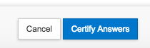
NOTE: If you can view the questions but cannot respond to them, make sure you are in Edit mode. If Edit mode is not an option, then ask the proposal creator to give you access to the proposal (on the Access section, with the role “Aggregator Only Document Level”).

When you have answered all of the questions and click the [Certify Answers] button, a pop-up window will appear stating “All questions answered” and provide you with three options:
- [Save and Exit] This will save all of your answers and exit the questionnaire.
- [Exit without save] This will not save any of your answers and exit the questionnaire.
- [Return To Questions] This will return you back to the questionnaire.

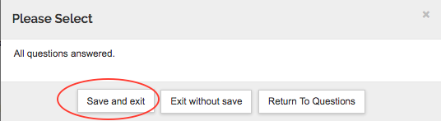

If you did not answer all of the questions and click the [Certify Answers] button, you will see “Please answer all questions in order to certify proposal”. Click [Return to Questions] to finish answering the questionnaire. OR, if you are not ready to finish, you may save your answers and come back to the questionnaire later by clicking on [Save and Exit]. You may return back to the questionnaire by clicking on the hyperlink in the certification email.

