Greetings All –

As promised back in October we wanted to make it easier for the departments to identify what team in SPAC serviced their award. We finally have the field on the Award Profile Card as shown below. If the award you have a question about happens to have our old team designations Red, White, Green or Blue please contact Asst Director Krista Salsberg ksalsberg@umaryland.edu or Director Michelle Ward michelle.ward@umaryland.edu. These outliers should be cleared up in the future. Or they are closed and will need a different type of attention.

SPAC TEAM | EMAIL | MANAGER
NONFED | billnonfed@umaryland.edu | Krissy Long
FED | billfed@umaryland.edu | Danijela Macakanja
VMS | billvms@umaryland.edu | Danijela Macakanja
QA (for all LOC awards) | spacffr@umaryland.edu | Hamid Badiei-Boushehri


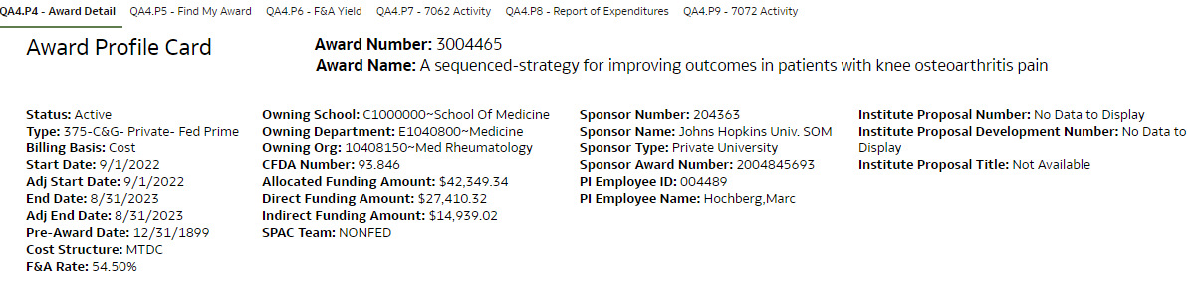

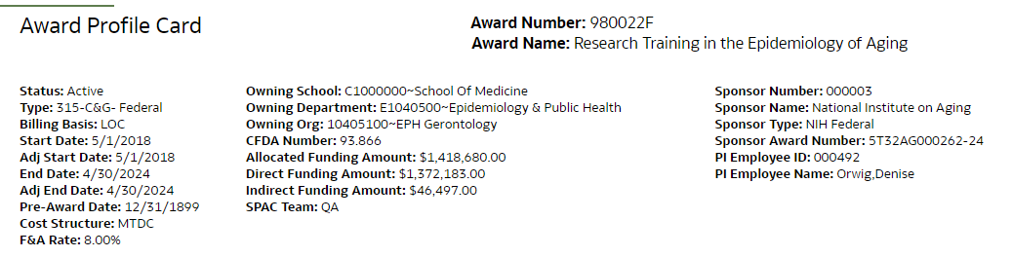

What you will not see on this profile card is the setup team. The setup team should only be contacted for
- When is my project going to be set up?
- My project is set up wrong.
- The PI, Sponsor or F&A is wrong on the project.
- Why is my project set up this way?
- Why can’t I have multiple projects?
- Why are the projects on different awards?
- Need cost share on my award.
- Question on child project
- Questions on Temp Awards unless it is to setup a Temp that goes to SPA.
- My budget is wrong on my award.
- My budget is not showing up in QA.
- Questions on NCE, expirations

If you are asking for a project to be opened so a charge or credit can come through, that request should be sent to the billing team not the setup team because there are a lot of implications of reopening an award after it has been reported. There may need to be a funding entry, a refund, or a change of final report to the sponsor. Normally after final reporting has been sent to the sponsor, we are not able to recuperate additional charges. However, we are required to refund any credits to the account.

