Taleo - HR Recruiting
Created on 5/5/2016 10:48:00 AM

“Approver Only” Role
Table of Contents
Taleo - HR Recruiting 1
Taleo Recruiting - Other Features 1
"Approver Only" Role 1

Taleo - HR Recruiting

Taleo Recruiting - Other Features

"Approver Only" Role
Procedure

This tutorial is for users who will only access Taleo when there is a requisition that they are required to approve. Users with this role do not have the ability to edit the requisition or view candidates.
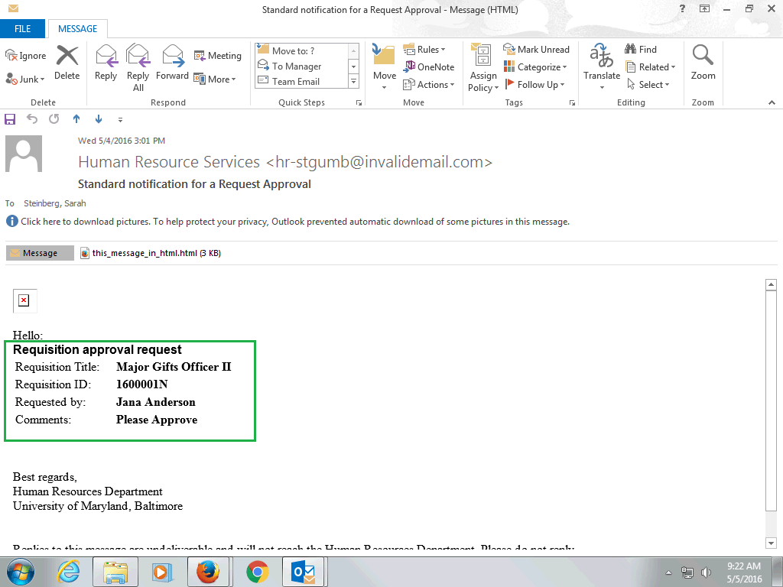

Step | Action
When a requisition is submitted for approval and you are the next approver, you will receive an e-mail that looks similar to this.

The sender will appear as Human Resource Services and the subject will say Standard notification for a Request Approval.

Once opened, the body will display the Requisition Title, ID, who requested approval and any comments.

To approve, you must access Taleo. If you are not familiar with how to do this, please review the Access & Overview tutorial.

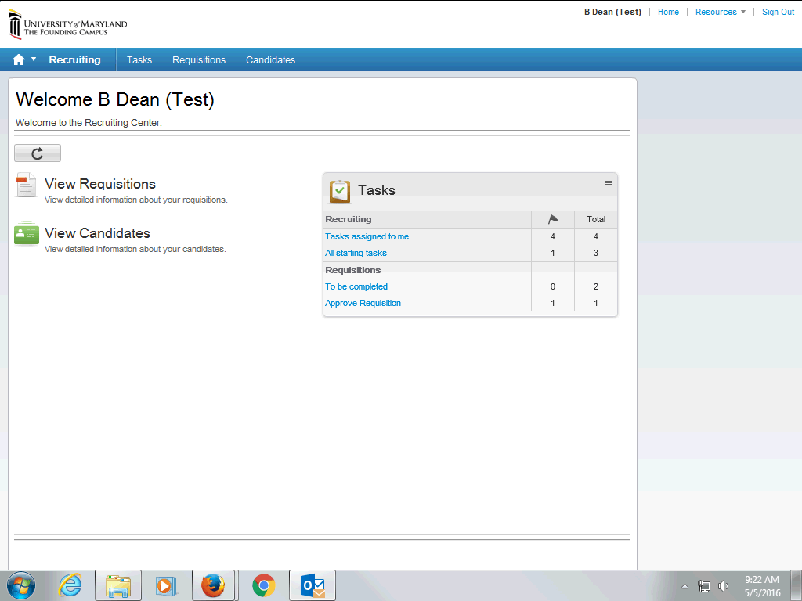

Step | Action
This is the Recruiting Center homepage as an approver will see it.

To quickly access any requisitions requiring approval, in the Tasks window, click the Approve Requisition link.

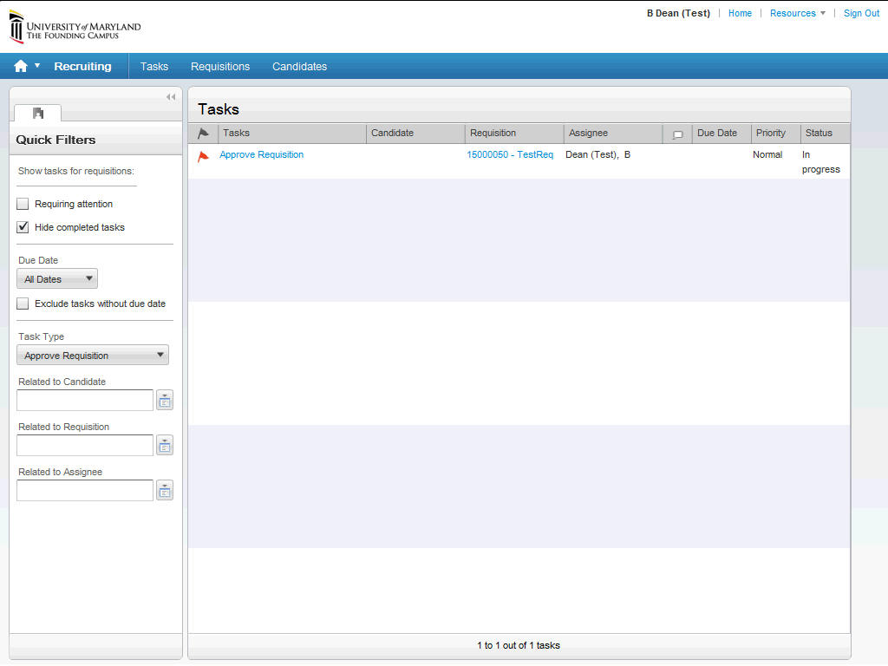

Step | Action
Any requisitions that require your approval will appear. The red flag denotes that the requisition hasn't been viewed yet.

To begin the approval, click the Approve Requisition link.

Note: One way to view the requisition before approving it is to click on the link in the Requisition column. A second way will be reviewed on the next screen.

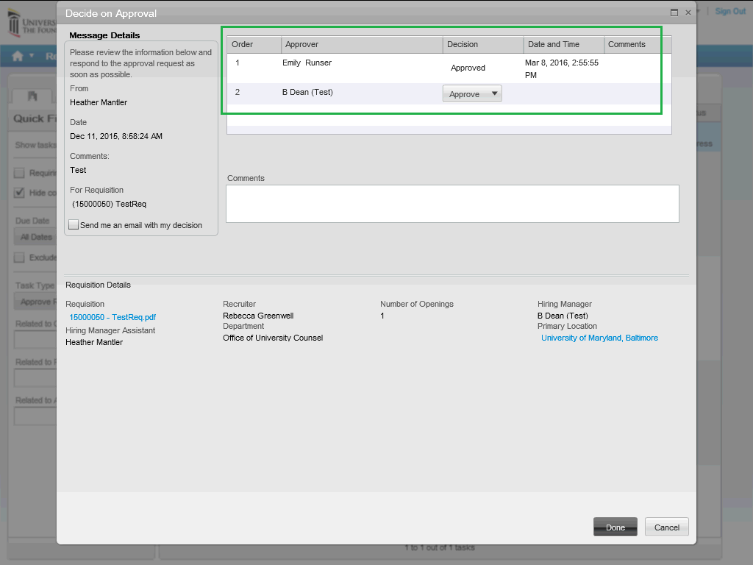

Step | Action
This is the Decide on Approval window. All required approvers will appear in the Approver section.

To view the requisition before approving it, you can access the .pdf version from this window.

Click the 15000050 - TestReq.pdf link.

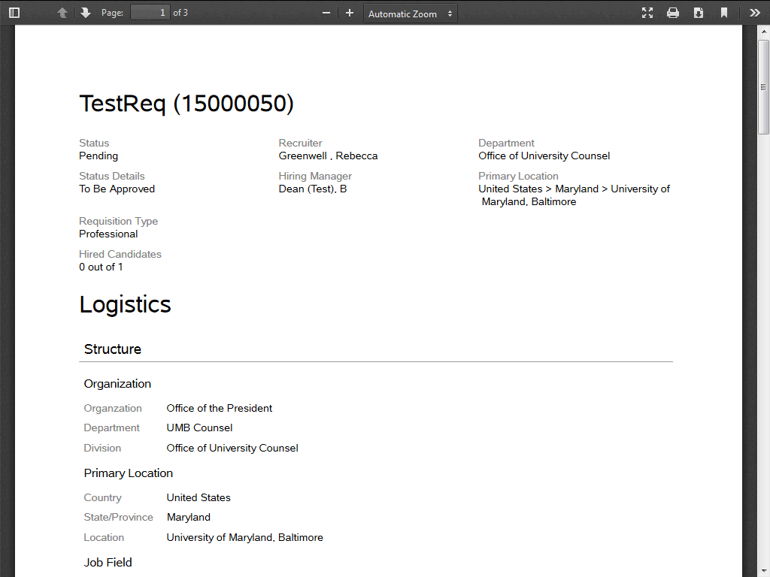

Step | Action
The requisition will open in another window. To continue viewing the requisition, Scroll Down.

Note: This is a test requisition and the data included is minimal compared to what you can expect to see in an actual requisition.

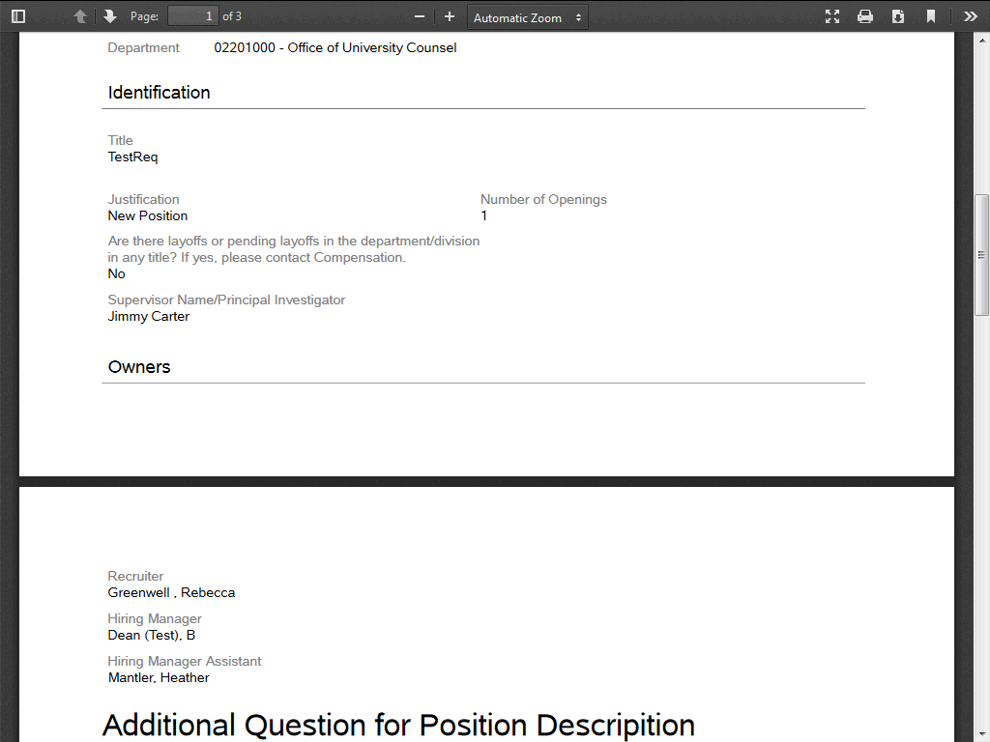

Step | Action
 | The various sections of the requisition will appear as you continue to Scroll Down.

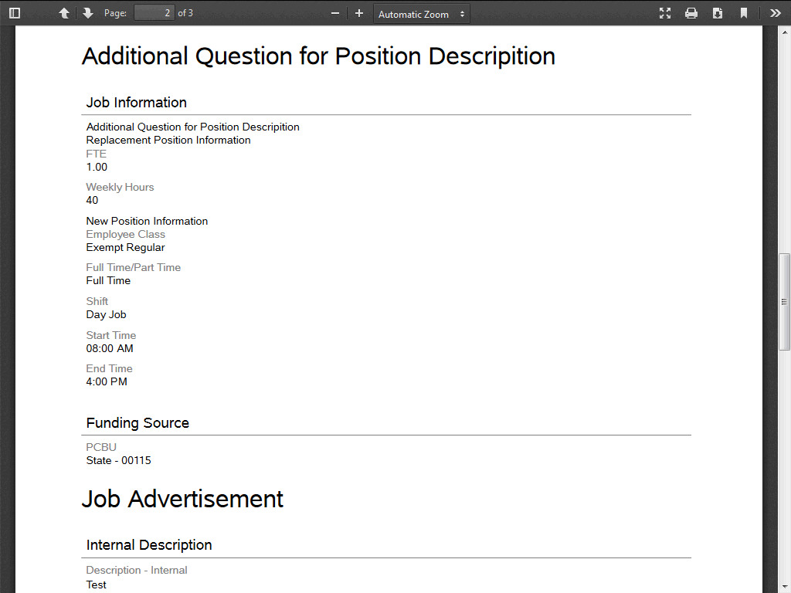

Step | Action
 | Continue to Scroll Down.

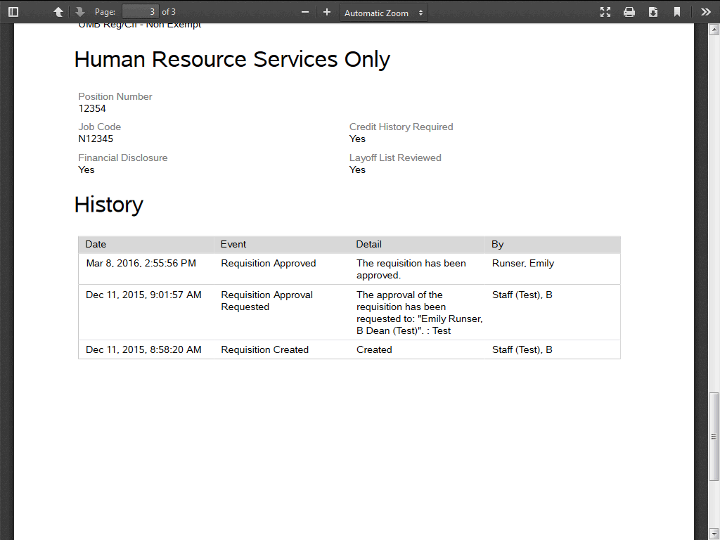

Step | Action
When you get to the end, you'll see the History section. This section will display what has happened to the requisiton so far and by whom.

One you're finished reviewing the requisition, you'll close the window to return to the approval page.

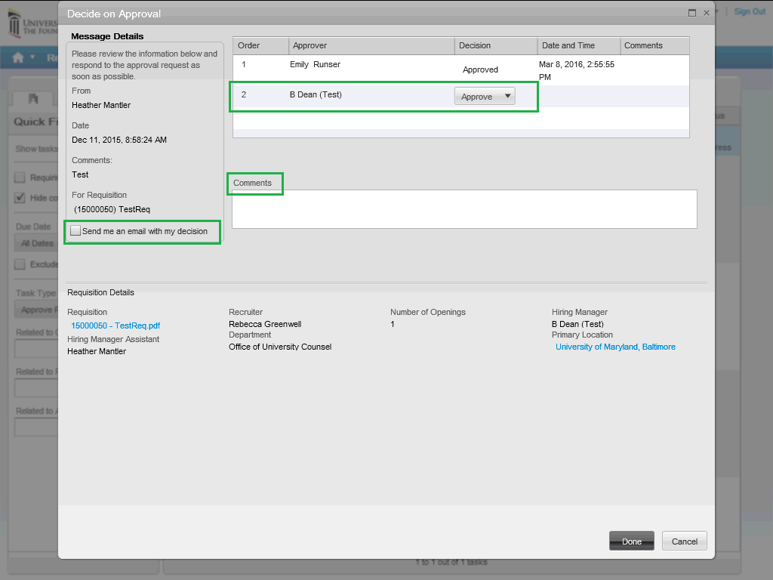

Step | Action
Next to your name in the approver section, the decision defaults to Approve. You can select the drop-down arrow and select Reject instead if it's necessary to send the requisition back.

Comments are optional but if there is anything information you want to convey, especially if you are rejecting the requisition, you can enter the information in the Comments section.

If you want to receive an e-mail with your decision, you can click the "Send me an email with my decision" box.

If everything is to your satisfaction and you are ready to approve it, click the Done button.

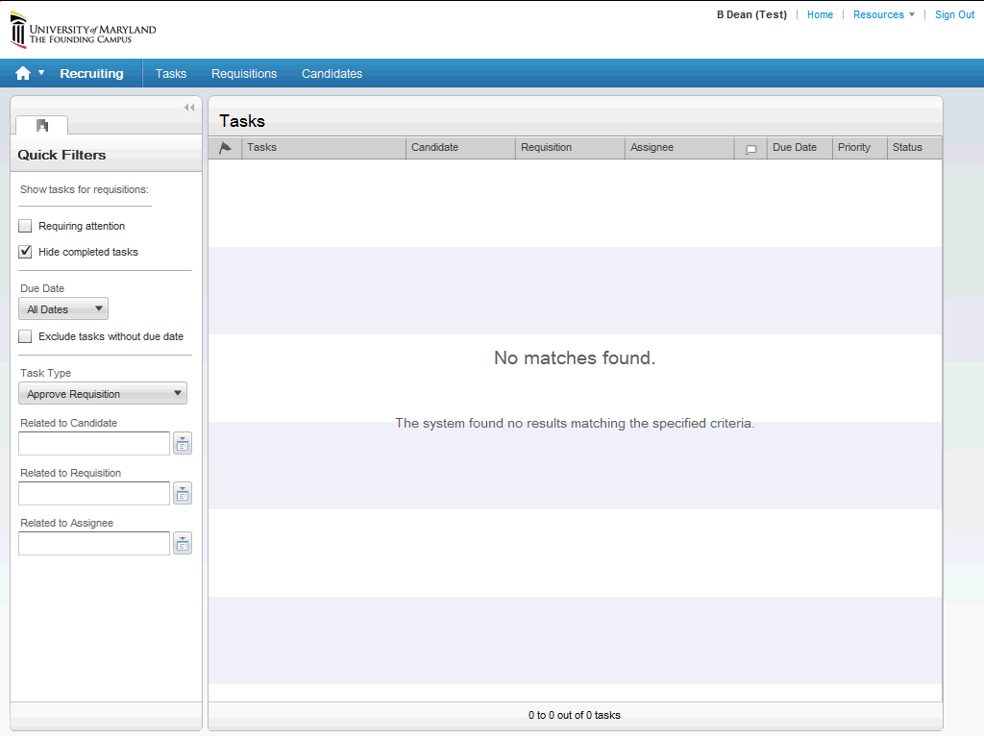

Step | Action
 | You'll be returned to the Tasks window. If there were any other requisitions to approve, they would appear. Otherwise, the list will appear as blank, as seen here.
This concludes the "Approver Only" Role tutorial. For further information on Taleo, please continue to review the tutorials.

For help with any questions or issues, please contact your Staffing Specialist at 6-7171.
End of Procedure.

