SECTION 102800 - TOILET, BATH, AND LAUNDRY ACCESSORIES

1. GENERAL
   * + 1. SUMMARY
          1. Section Includes:

Public-use washroom accessories.

Framed mirror units.

Custodial accessories.

Grab bars.

* + - 1. ACTION SUBMITTALS
         1. Product data.
         2. Include construction details, material descriptions, dimension of individual components and profiles, and finishes.
         3. Include anchoring and mounting requirements, including requirements for cutouts in other work and substrate preparation.
      2. WARRANTY
         1. Manufacturer's Special Warranty for Mirrors: Manufacturer agrees to repair or replace mirrors that fail in materials or workmanship within specified warranty period.

Warranty Period: 10 years from date of Substantial Completion.

1. PRODUCTS
   * + 1. PERFORMANCE REQUIREMENTS
          1. Electrical Components, Devices, and Accessories: Listed and labeled as defined in NFPA 70, by a qualified testing agency, and marked for intended location and application.
          2. Structural Performance: Design accessories and fasteners to comply with the following requirements:

Grab Bars: Installed units are able to resist 250 lbf concentrated load applied in any direction and at any point.

Shower Seats: Installed units are able to resist 360 lbf concentrated load applied in any direction and at any point.

* + - 1. PUBLIC-USE WASHROOM ACCESSORIES
         1. Toilet Tissue (Roll) Dispenser **<Insert drawing designation>**:

Product: Kimberly Clark; Cored JRT Jumbo Combo Tissue Dispenser, #09551 Smoke/Gray.

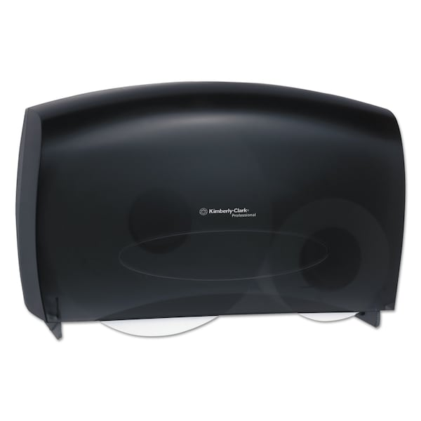Capacity: Designed for 9- or 10-inch-diameter tissue rolls.

Material and Finish: ABS plastic housing, built-in anti-microbial protection, and Translucent front cover.

Refill indicator: Pierced slots at front.

* + - * 1. Paper Towel (Roll) Dispenser for Public Restrooms **<Insert drawing designation>**:

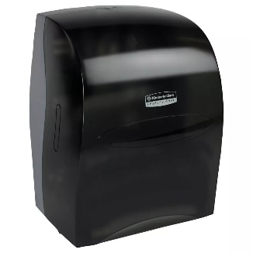Product: Kimberly Clark: Sanitouch #09990, Smoke Gray.

Dimensions: 12.63” x 16.13” x 10.2” deep.

Description: Pull-towel-actuated mechanism that permits controlled delivery of paper rolls in preset lengths.

Minimum Capacity: 8-inch-wide, 800-foot-long roll.

Lockset: Tumbler type.

* + - * 1. 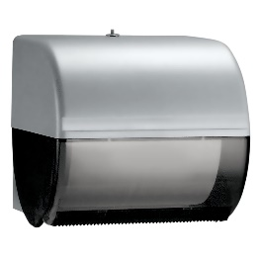Paper Towel (Roll) Dispenser for Kitchenettes and Laboratory Sink Areas: **<Insert drawing designation>**:

Product: Kimberly Clark: Sanitouch #09746, Smoke.

Dimensions: 10.5” x 10.0” x 10.0” deep.

Minimum Capacity: 8-inch-wide, 800-foot-long roll.

Lockset: Tumbler type.

* + - * 1. Countertop-Mounted Circular Waste Chute **<Insert drawing designation>**:

Product: Bobrick: Countertop-mounted circular waste chute, #529.

Outside Dimension: 6 inches.

Material and Finish: Stainless steel.

* + - * 1. Waste Receptacle (listed for coordination with countertop-mounted waste chutes): Rubbermaid; Slim Jim Container #3540, supplied by Owner.
        2. Warm-Air Hand Dryer (reserved for future direction from UMB):

Products: Standard-speed, warm-air hand dryer.

Mounting: Semi-recessed or Surface-mounted.

Protrusion Limit: Limit protrusion in access aisleway with leading edge between 27 and 80 inches above finished floor to 4 inches from wall surface.

Operation: Infrared-sensor activated with timed power cut-off switch.

Electrical Requirements: TBD.

* + - * 1. Soap Dispenser <Insert drawing designation>:

Description: Designed for operation and dispensing soap in liquid or lotion form.

Note: The University EVS will provide Classic Manual soap dispenser. If Classic Touch-Free dispensers are chosen they are to be purchased by the Department- EVS will refill these dispensers but the battery replacement is the responsibility of the Department.

<EcoLab #92023091 NEXA Manual Compact Dispenser in Black.>

<EcoLab #92021193 NEXA Touch-Free Compact Dispenser in Black.>

Mounting: Vertically oriented, surface mounted.

Capacity: 1250 ml.

* + - * 1. Grab Bar <Insert drawing designation>:

Mounting: Flanges with concealed fasteners.

Material: Stainless steel, 0.05 inch thick.

Finish: Smooth, ASTM A480/A480M No. 4 finish (satin) on ends and slip-resistant texture in grip area.

OD: 1-1/2 inches.

Configuration and Length: As indicated on Drawings.

* + - * 1. Seat-Cover Dispenser <Insert drawing designation>:

Product: Bobrick model B-221.

Mounting: Surface mounted.

Minimum Capacity: 250 seat covers.

Exposed Material and Finish: Stainless steel with satin finish.

Lockset: Tumbler type.

* + - * 1. Mirror Unit <Insert drawing designation>:

Product: Bobrick B-290

Frame: 304 Stainless steel angle, 0.05 inch thick, satin finish.

Welded corners, galvanized steel back.

Size: As indicated on Drawings.

* + - * 1. Hook <Insert drawing designation>:

Product: Bobrick model #B-2116.

Description: Single-prong unit.

Mounting: Concealed.

Material and Finish: Stainless steel, ASTM A480/A480M No. 4 finish (polished).

* + - 1. CHILDCARE ACCESSORIES
         1. Diaper-Changing Station <**Insert drawing designation**>:

Product: Koala Kare model #KB310-SSRE.

Description: Horizontal unit that opens by folding down from stored position and with child-protection strap.

Engineered to support minimum of 250 lb static load when opened.

Mounting: Recessed, with unit projecting not more than 3 inches from wall when closed.

Operation: By pneumatic shock-absorbing mechanism.

Material and Finish: Stainless steel, ASTM A480/A480M No. 4 finish (satin), with replaceable insulated polystyrene tray liner and rounded plastic corners.

Liner Dispenser: Provide built-in dispenser for disposable sanitary liners.

* + - 1. UNDERLAVATORY GUARDS
         1. Underlavatory Guard <Insert drawing designation>:

Product: LavBro.

Description: Insulating pipe covering for supply and drain piping assemblies that prevents direct contact with and burns from piping; allow service access without removing coverings.

Material and Finish: Antimicrobial, molded plastic, white.

* + - 1. CUSTODIAL ACCESSORIES
         1. Custodial Mop and Broom Holder <**Insert drawing designation**>:

Product: Bobrick model #B-239 x 34 or #B-224 X 36.

Description: Unit with shelf, hooks, holders, and rod suspended beneath shelf.

Length: 34 inches.

Hooks: Four.

Mop/Broom Holders: Three, spring-loaded, rubber hat, cam type.

Material and Finish: Stainless steel, No.4 finish (satin).

* + - * 1. 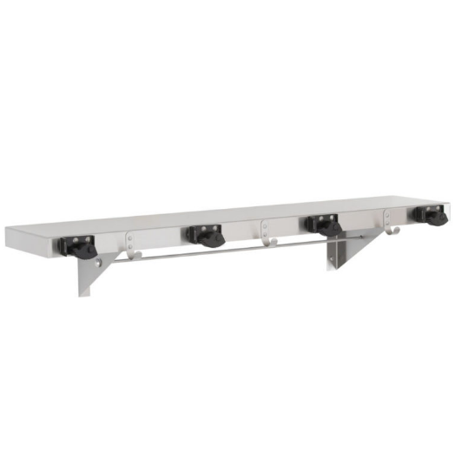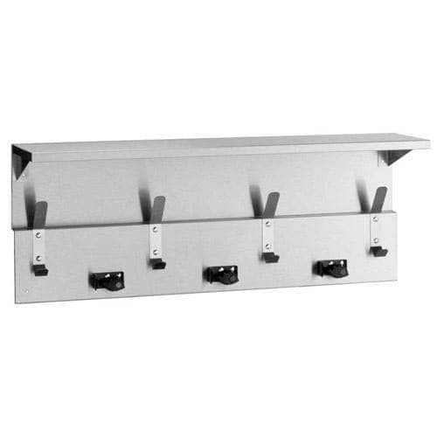
        2. B-229 B-224
      1. FABRICATION
         1. Keys: Provide universal keys for internal access to accessories for servicing and resupplying. Provide minimum of six keys to Owner's representative.

1. EXECUTION
   * + 1. INSTALLATION
          1. Install accessories in accordance with manufacturers' written instructions, using fasteners appropriate to substrate indicated and recommended by unit manufacturer. Install units level, plumb, and firmly anchored in locations and at heights indicated.

Remove temporary labels and protective coatings.

* + - * 1. Grab Bars: Install to comply with specified structural-performance requirements.

END OF SECTION 102800