https://www.umaryland.edu/spac/external-communication-plan-for-spac/
Setup Team: All Sources All Billing Basis
RS-SPAC Setup or spacsetup@umaryland.edu
Director: Michelle Ward, michelle.ward@umaryland.edu
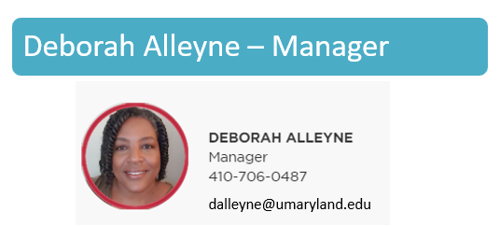
Questions for Setup Team
- When is my project going to be set up
- My project is setup wrong
- The PI, Sponsor or F&A is wrong on the award
- Why is my project set up this way
- Why can’t I have multiple projects
- Why are the projects on different awards.
- Need cost share on my award
- Question on a child project
- Questions on Temp Awards unless it is to setup a temp which would first start at SPA
- My budget is wrong on my award
- My budget is not showing up in QA
- Questions on NCE, expirations

BILLING TEAMS:
Director: Michelle Ward, michelle.ward@umaryland.edu
Assistant Director: Krista Salsberg, ksalsberg@umaryland.edu
Questions for Billing Team
- Where is my bill
- I need to do an adj on my ROE
- Why did you bill this way
- Questioned costs on billing
- Need to bill this project
- Sponsor contacted me about the bill

THERE ARE 3 BILLING TEAMS NONFED, FED, VMS

NONFED BILLING TEAM
RS-SPAC Billing Non Fed or
billnonfed@umaryland.edu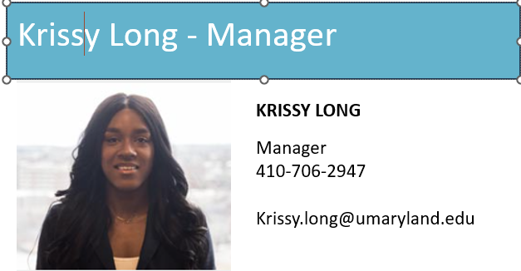

SOURCE: 335 C&G State & Local
345 C&G State & Local Fed P
365 C&G Private
375 C&G Private Fed P
BILLING BASIS: COST
SCHEDULE/COST
FED BILLING TEAM
RS-SPAC Billing Fed or billfed@umaryland.edu
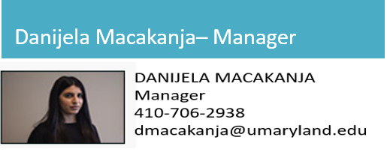

SOURCE: 315- C&G Federal
BILLING BASIS: COST
SCHEDULE/COST
VMS BILLING TEAM
RS-SPAC Billing Vol_Mile_Schd or billvms@umaryland.edu
SOURCE: 315- C&G Federal
335 C&G State & Local
345 C&G State & Local Fed P
365 C&G Private
375 C&G Private Fed P

BILLING BASIS: VOLUME
MILESTONE
SCHEDULE

REPORTING, COLLECTION & AR AND COST
Director: Rama Camara Spasic rcamaraspasic@umaryland.edu

FFR REPORTING TEAM (aka Quality Assurance)
RS-SPAC Fed Fin Report or spacffr@umaryland.edu
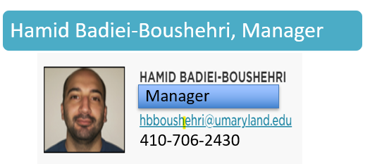
Questions for FFR Team
- I need my FFR submitted
- Why was my FFR submitted for that amount
- My FFR seems incorrect
- Question on Draws
- Who can sign my FFR
- Why was my FFR submitted w/out signature
Quality Assurance Behind the scenes tasks
- Reconciliations
- Refunds
- Relinquishment
- Audits
- Year End
CAR TEAM (aka Collections and Accounts Rec)
RS-SPAC Collections or spaccollections@umaryland.edu
Janel Williams, Supervisor
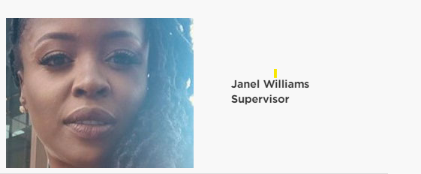
jwilliams@umaryland.edu
410-706-2927
Questions for CAR Team
- Banking information
- ACH or vendor form needs to be filled out
- Have you received my payment
- Why is my payment not showing posted
- How do I obtain a W-9 for a sponsor
- Can I receive the original invoices with my collection letter
- Are you sending a Dunning Letter to this sponsor
- Can you stop dunning a sponsor
- I have a payment in my office how do I get it applied
- My sponsor wants to institute a payment plan

COST ANALYSIS AND COMPLIANCE TEAM
RS-SPAC Effort Reporting Help or effort@umaryland.edu
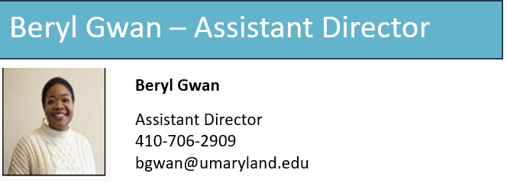
Questions for Cost Team
- How to do a DR or a BR
- How do you calculate fringe
- Where is our fringe letter
- Where Is our F&A letter
- F&A rate questions
- Service Center questions
- Effort questions

ADMINISTRATIVE TEAM
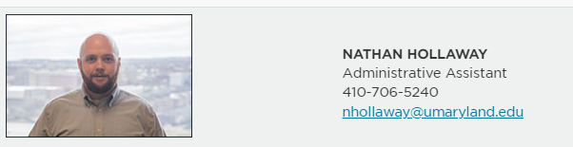
Questions for Administrative Team
- I have a survey that needs to be filled out
- I need audited financial statement
- I need an A133 subrecipient survey filled
- I need vendor banking information (if CAR did not answer)
- Any PRE-AWARD needs should be handled by SPA and if you need further financial information, please forward to Nathan

